Combinatorial Number Problem

Problem Description
The combinatorial number 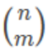 indicates the number of options to select m items out of n items. For example, choosing two items out of three items (1,2,3) can be done in three ways: (1,2),(1,3),(2,3). Based on the definition of combinatorial numbers, we can give a general formula for calculating the combinatorial number:
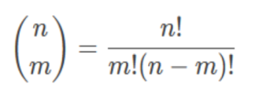
Where n!= 1 × 2 × ... × n; In particular, define 0!= 1.

Xiaocong wants to know if given n, m and k, for all 0 ≤ i ≤ n, 0 ≤ j ≤ min(i, m), how many pairs of (i, j) satisfy that 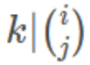.

Input
The first line has two integers t and k, where t represents how many sets of test data there are in total at that test point. The meaning of k is described in the problem description.

Next t lines each have two integers n and m, and the meanings of n and m are shown in the problem description.

Output
There are t lines, each line with an integer representing 0 ≤ i ≤ n, 0 ≤ j ≤ min(i,m). how many pairs of the (i, j) with .

Sample Input 1
1 2
3 3

Sample Output 1
1

Sample Input 2
2 5
4 5
6 7

Sample Output 2
0
7

Hint
[Explanation of Sample 1]
Of all the possible cases, only 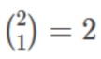 is a multiple of 2.

[Subtask]
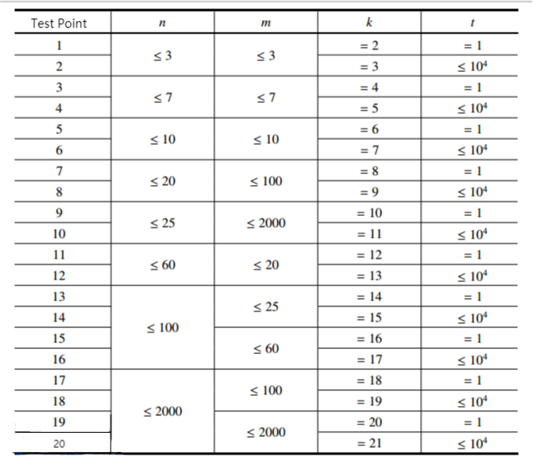

- For all test points, make sure 0 ≤ n, m ≤ 2 × 10³, 1 ≤ t ≤ 10⁴.

